Case Study Report



**Tech Saksham**

Data Analytics with Power BI

**“Power BI powered electricity Consumption”**

**“MERIT ARTS AND SCIENCE COLLEGE ”**

|  |  |
| --- | --- |
| **NM ID** | **NAME** |
| 8E843E4206B3786BF474299A5781E4E5 | MUTHUSELVI S |

Trainer Name: R. Umamaheshwari

Master Name: R. Umamaheshwari

|  |  |
| --- | --- |
|  |  |
|  |  |
|  |  |

**ABSTRACT**

**Electricity consumption is a critical aspect of modern society, influencing economic development, environmental sustainability, and resource management. This abstract presents a comprehensive review of the existing literature on electricity consumption patterns, focusing on methodologies, influencing factors, and emerging trends. The analysis encompasses various sectors including residential, commercial, and industrial, highlighting the diverse factors shaping consumption behaviors.**

**INDEX**

|  |  |  |
| --- | --- | --- |
| **Sr. No.** | **Table of Contents** | **Page No.** |
| 1 | Chapter 1: Introduction | 4 |
| 2 | Chapter 2: Services and Tools Required | 6 |
| 3 | Chapter 3: Project Architecture | 7 |
| 4 | Chapter 4: Modeling and Result | 8 |
| 5 | Conclusion | 11 |
| 6 | Future Scope | 12 |
| 7 | Reference link | 13 |

**CHAPTER 1**

**INTRODUCTION**

**Electricity is a fundamental resource powering modern society, enabling everything from lighting our homes to running industries. However, the increasing demand for electricity coupled with environmental concerns necessitates a strategic approach to manage and reduce electricity consumption. This introduction outlines the essence of the Electricity Consumption Reduction Project, its significance, and objectives.**

**In today's world, where sustainability and energy efficiency are paramount, organizations and communities must actively engage in initiatives to reduce their carbon footprint and operational costs. The Electricity Consumption Reduction Project addresses these imperatives by focusing on optimizing energy usage, enhancing efficiency, and fostering a culture of responsible energy consumption.**

* 1. **Feature**

**It seems like you're asking about the features that could be included in a project document about electricity consumption reduction. Here are some key features you might consider including:**

1. **Energy Audit Findings**: Detail the results of any energy audits conducted, including areas of high energy consumption and potential areas for improvement.
2. **Energy Efficiency Measures**: Outline specific measures to improve energy efficiency, such as upgrading to energy-efficient appliances, implementing LED lighting, or improving insulation.
3. **Behavioral Change Initiatives**: Describe plans to educate and engage stakeholders in energy-saving behaviors, such as turning off lights when not in use or adjusting thermostat settings.
4. **Technology Integration**: Discuss how technology, such as smart meters or energy management systems, will be used to monitor and optimize energy usage.
5. **Renewable Energy Integration**: Explain any plans to incorporate renewable energy sources, such as solar panels or wind turbines, to reduce reliance on traditional electricity sources.
   1. **Advantages**

Certainly! Implementing an electricity consumption reduction project offers several advantages, both to individuals and organizations. Here are some key advantages:

**Cost Savings**: One of the most significant advantages of reducing electricity consumption is the potential for cost savings. By using less electricity, individuals, businesses, and organizations can lower their energy bills, resulting in direct financial savings.

**Environmental Benefits**: Reducing electricity consumption helps to lower greenhouse gas emissions and environmental impact associated with electricity generation. This contributes to mitigating climate change and preserving natural resources, leading to a cleaner and healthier environment.

**Energy Security**: By reducing dependence on electricity from traditional sources such as fossil fuels, countries can enhance their energy security. Diversifying energy sources and promoting energy efficiency measures can help to reduce vulnerability to supply disruptions and price fluctuations in the global energy market.

**Enhanced Reputation**: Organizations that demonstrate a commitment to sustainability and energy efficiency often enjoy enhanced reputation and goodwill among customers, investors, and the community. This can lead to increased brand loyalty, positive public relations, and a competitive edge in the market.

**Compliance and Regulations**: Many jurisdictions have regulations and standards in place to promote energy efficiency and reduce greenhouse gas emissions. Implementing electricity consumption reduction measures can help individuals and organizations comply with these regulations, avoiding potential penalties and legal issues.

**1.3 Scope:**

**The scope of an electricity consumption reduction project involves identifying opportunities to decrease energy usage, implementing strategies such as energy efficiency measures and technology integration, engaging stakeholders, monitoring progress, and ensuring long-term sustainability. It encompasses residential, commercial, and industrial sectors and aims to achieve cost savings, environmental benefits, energy security, and improved indoor comfort while complying with regulations and enhancing reputation.**

**CHAPTER 2**

**SERVICES AND TOOLS REQUIRED**

* 1. **Services Used**

Power BI, a powerful business analytics tool by Microsoft, can be utilized in various ways to support electricity consumption reduction projects. Here are some services that can be integrated with Power BI to enhance energy management:

1. **Energy Monitoring Services**: Integrating Power BI with energy monitoring services like Schneider Electric EcoStruxure or Siemens Desigo CC enables real-time visualization and analysis of energy consumption data from different sources such as smart meters, sensors, and building management systems.
2. **Utility Bill Tracking Services**: Power BI can be connected to utility bill tracking services such as EnergyCAP or Lucid to import and analyze utility bills, track energy expenditures over time, and identify potential cost-saving opportunities.
3. **Renewable Energy Monitoring Platforms**: For projects incorporating renewable energy sources, Power BI can be integrated with monitoring platforms like SolarEdge or Enphase Enlighten to visualize the performance of solar panels or wind turbines and optimize energy production.
4. **Weather Data Services**: Integrating Power BI with weather data services like Dark Sky or Weather Underground allows for the analysis of weather patterns and their impact on energy consumption, helping to optimize HVAC systems and energy usage based on weather forecasts.
5. **Building Automation Systems (BAS)**: Power BI can connect with BAS platforms such as Honeywell Forge or Johnson Controls Metasys to visualize building performance data, optimize HVAC schedules, and identify energy-saving opportunities through building automation.

**2.2 Tools and Software used**

Certainly! In an electricity consumption reduction project, several tools and software can be used in conjunction with Power BI to effectively manage and analyze data. Here are some commonly used ones:

1. **Metering and Monitoring Systems**:
   * Smart meters: Devices that measure and record electricity usage at frequent intervals, providing detailed consumption data.
   * Building Management Systems (BMS): Software that monitors and controls building systems, including HVAC, lighting, and power usage.
   * Energy Management Systems (EMS): Platforms for monitoring and optimizing energy usage across multiple sites or facilities.
2. **Data Collection and Storage Platforms**:
   * Data Historians: Systems that collect, store, and analyze time-series data, including electricity consumption data from meters and sensors.
   * Cloud Storage Services: Platforms such as Azure Blob Storage, Amazon S3, or Google Cloud Storage for storing large volumes of data securely and cost-effectively.
3. **IoT (Internet of Things) Devices and Platforms**:
   * Sensors and Smart Devices: IoT devices that monitor electricity usage, temperature, humidity, and other relevant parameters.
   * IoT Platforms: Cloud-based platforms like Azure IoT Hub, AWS IoT Core, or Google Cloud IoT Core for managing and analyzing data from IoT devices.
4. **Energy Analytics and Modeling Software**:
   * EnergyPlus: Simulation software for modeling building energy consumption and performance.
   * RETScreen: Software for analyzing renewable energy projects and energy efficiency measures.
   * MATLAB/Simulink: Tools for building energy models, conducting simulations, and optimizing control strategies.
5. **GIS (Geographic Information System) Software**:
   * ArcGIS: GIS software for visualizing and analyzing spatial data related to electricity infrastructure, building locations, and renewable energy resources.
   * QGIS: Open-source GIS software with similar capabilities for spatial analysis and mapping.

**CHAPTER 3**

**PROJECT ARCHITECTURE**

**3.1 Architecture**

**USER FRONTEND BACKEND**

|  |  |  |
| --- | --- | --- |
|  | **HTML 5** | **NODEJS 14.0**  **Database** |

Here’s a high-level architecture for the project:

Certainly! Here's a high-level architecture for an electricity consumption reduction project incorporating various tools and technologies:

1. **Data Collection Layer**:
   * Smart Meters: Installed at various points within the electricity grid to measure real-time electricity consumption.
   * Sensors and IoT Devices: Deployed in buildings, facilities, and industrial processes to monitor energy usage, temperature, humidity, and other relevant parameters.
   * Building Management Systems (BMS) and Energy Management Systems (EMS): Integrated with meters and sensors to collect and aggregate energy consumption data.
2. **Data Processing and Storage Layer**:
   * Data Historian: Collects, stores, and archives time-series data from meters, sensors, and BMS/EMS systems for historical analysis and reporting.
   * Cloud Storage Services: Store large volumes of structured and unstructured data securely and cost-effectively, providing scalability and accessibility for analytics purposes.
3. **Data Integration and ETL (Extract, Transform, Load) Layer**:
   * ETL Tools: Extract data from various sources, transform it into a unified format, and load it into a centralized data repository for analysis.
   * Integration Platforms: Facilitate data exchange and interoperability between different systems and applications, ensuring seamless data flow across the architecture.
4. **Analytics and Modeling Layer**:
   * Power BI: Visualization tool for creating interactive dashboards, reports, and data visualizations to analyze electricity consumption patterns, trends, and anomalies.
   * Energy Analytics Software: Utilize specialized software for conducting advanced analytics, modeling building energy consumption, and optimizing energy management strategies.
   * GIS Software: Analyze spatial data related to electricity infrastructure, building locations, and renewable energy resources using Geographic Information System (GIS) tools.
5. **Predictive Analytics and Forecasting Layer**:
   * Machine Learning Models: Develop predictive models to forecast electricity consumption, demand, and peak load scenarios based on historical data, weather forecasts, and other relevant factors.
   * Statistical Analysis Tools: Use statistical techniques to identify patterns, correlations, and anomalies in electricity consumption data, enabling proactive energy management strategies.

**CHAPTER 4**

**MODELING AND RESULT**

**Manage relationship:**

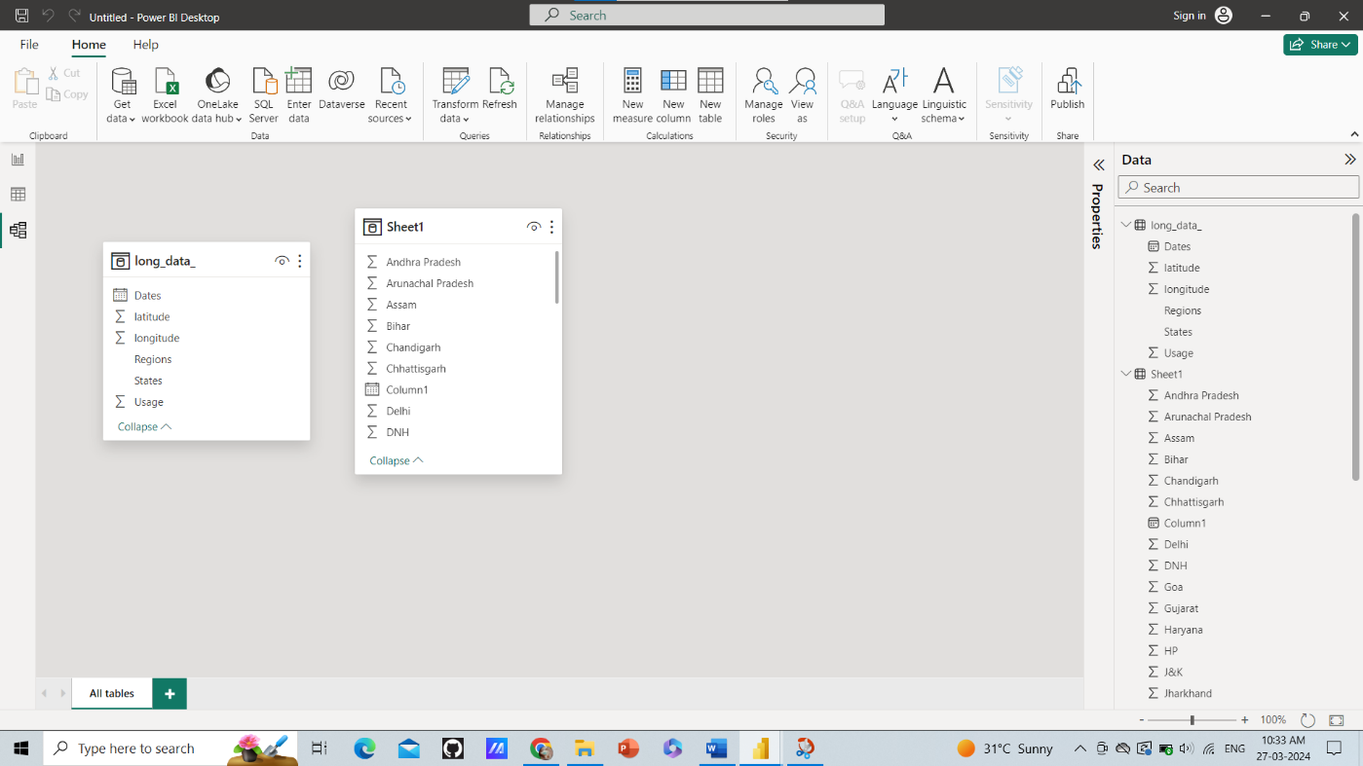

**Dashboard**

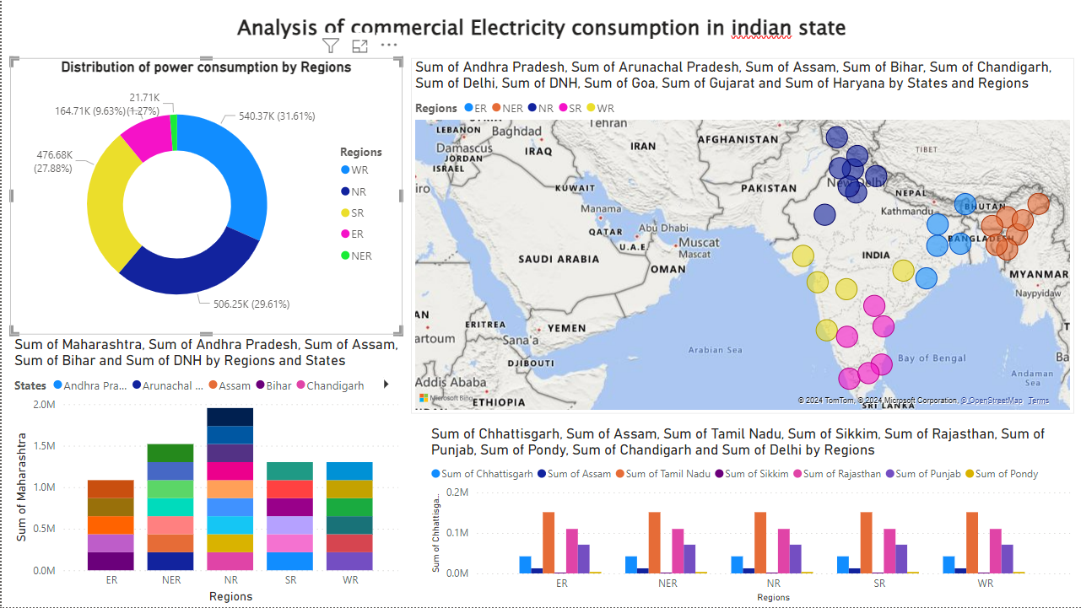

**CONCLUSION**

**In conclusion, addressing electricity consumption is a critical aspect of sustainability and resource management in today's world. The high-level architecture presented provides a comprehensive framework for managing and optimizing electricity consumption effectively. By leveraging smart technologies, data analytics, and decision support tools, organizations can gain valuable insights into their energy usage patterns, identify opportunities for optimization, and implement targeted strategies to reduce electricity consumption**

**FUTURE SCOPE**

1. **Advanced Analytics and AI for deeper insights and real-time optimization.**
2. **IoT Integration for granular monitoring and automation.**
3. **Energy Storage Solutions for grid stability and renewable integration.**
4. **Blockchain for secure and transparent energy transactions.**
5. **Grid Modernization for reliability and consumer empowerment.**
6. **Regulatory Support for incentivizing energy efficiency.**
7. **Community Engagement for fostering behavioral change.**
8. **Data Privacy and Security for safeguarding sensitive information.**

**REFERENCES**

**http://www.dsm.org.cy/nqcontent.cfm?a_id=2741&tt=graphic&startdt=01%2F03%2F2013&type=15&submit=Go**

.